Practical No:10
Name of Student | Perin Patel
PRN No. | 26070122259
Batch | B3
Class | CSE
Academic Year & Semester | 2026/27 & SEM-1
Date of Performance | 22/10/2026
Title of Assignment: | Simple Sentiment Analysis of Tweets using Python
Objective | To understand the concept of sentiment analysis of social media text.  To perform tweet sentiment classification using VADER polarity scores.  To learn how to compute and interpret compound sentiment scores.
Theory: | 1. Sentiment Analysis  Sentiment analysis is a Natural Language Processing (NLP) technique used to determine whether a piece of text expresses positive, negative, or neutral emotion. It is widely used for analyzing tweets, reviews, feedback, and public opinion.  2. VADER (Valence Aware Dictionary and Sentiment Reasoner) – Short Explanation  VADER is a pre-trained, rule-based sentiment analysis tool specifically designed for social media text.  It effectively handles:  - Slang (e.g., “awesome”, “terrible”)  - Emojis (😊😡😭)  - Emphasis (ALL CAPS, !!!, ???)  - Sentiment intensity words (“very good”, “extremely bad”)  VADER produces four outputs:  - pos → proportion of positive words  - neg → proportion of negative words  - neu → proportion of neutral content  - compound → single score that summarizes overall sentiment  3. Compound Score – Short Explanation  The compound score is the most important output of VADER.  It is a normalized score ranging from –1 (most negative) to +1 (most positive).  Using this score, sentiment is classified as:  - Positive → compound ≥ +0.05  - Negative → compound ≤ –0.05  - Neutral → otherwise  The compound score is preferred because it gives one final sentiment value while automatically considering intensity, punctuation, emojis, and emphasis.
Source Code/Algorithm/Flow Chart: | - Load the dataset of tweets (CSV file).  - Apply text preprocessing (remove URLs, mentions, emojis, symbols).  - Initialize the VADER SentimentIntensityAnalyzer.  - For each cleaned tweet, compute polarity scores.  - Extract the compound score.  - Classify sentiment as positive, negative, or neutral using thresholds.  - Store and display results.  - (Optional) Calculate accuracy if true labels exist.
Practice Programs: | !pip3 install pandas nltk  import nltk  nltk.download('vader_lexicon')  import pandas as pd  import re  from nltk.sentiment import SentimentIntensityAnalyzer  # 1. Load the dataset  # The actual headers are in the second row (index 1) of the CSV  # Based on the previous df.head() output, pd.read_csv(header=1) resulted in 'Unnamed: X' columns,  # and the actual headers ('id', 'tweetText') were loaded as the first row of data (df.iloc[0]).  # We will load with header=1 as originally intended, but then manually correct the column names.  df = pd.read_csv("tweets.csv", header=1) # make sure tweets.csv is in the same folder  # Correct column names: use the first row of the loaded DataFrame as column headers  df.columns = df.iloc[0]  # Drop the row that was just used as headers  df = df[1:].reset_index(drop=True)  print("Sample data after correcting headers:")  print(df.head())  # 2. Basic preprocessing function  def clean_tweet(text):  text = str(text)  text = text.lower()  text = re.sub(r"http\S+|www\S+|https\S+", "", text) # remove URLs  text = re.sub(r"@\w+", "", text) # remove mentions  text = re.sub(r"#", "", text) # remove hashtag symbol  text = re.sub(r"[^a-zA-Z\s]", "", text) # keep only letters and spaces  text = re.sub(r"\s+", " ", text).strip() # remove extra spaces  return text  # Apply cleaning to the 'tweetText' column  df["clean_tweet"] = df["tweetText"].apply(clean_tweet)  print("\nCleaned tweets:")  print(df[["tweetText", "clean_tweet"]].head())  # 3. Initialize VADER  sia = SentimentIntensityAnalyzer()  # 4. Function to get sentiment label from compound score  def get_sentiment_label(score, pos_thresh=0.05, neg_thresh=-0.05):  if score >= pos_thresh:  return "positive"  elif score <= neg_thresh:  return "negative"  else:  return "neutral"  # 5. Apply sentiment analysis  compound_scores = []  sentiment_labels = []  for t in df["clean_tweet"]:  scores = sia.polarity_scores(t)  #print(scores)  compound = scores["compound"]  compound_scores.append(compound)  sentiment_labels.append(get_sentiment_label(compound))  df["compound_score"] = compound_scores  df["predicted_sentiment"] = sentiment_labels  print("\nSentiment results:")  print(df[["tweetText", "clean_tweet", "compound_score", "predicted_sentiment"]])  # 6. (Optional) Evaluate accuracy if true labels are available  if "label" in df.columns:  correct = (df["label"].str.lower() == df["predicted_sentiment"].str.lower()).sum()  total = len(df)  accuracy = correct / total * 100  print(f"\nAccuracy: {accuracy:.2f}% ({correct}/{total})")  # 7. Save results to a new CSV  df.to_csv("tweets_with_sentiment.csv", index=False)  print("\nResults saved to tweets_with_sentiment.csv")
Output Screenshots | 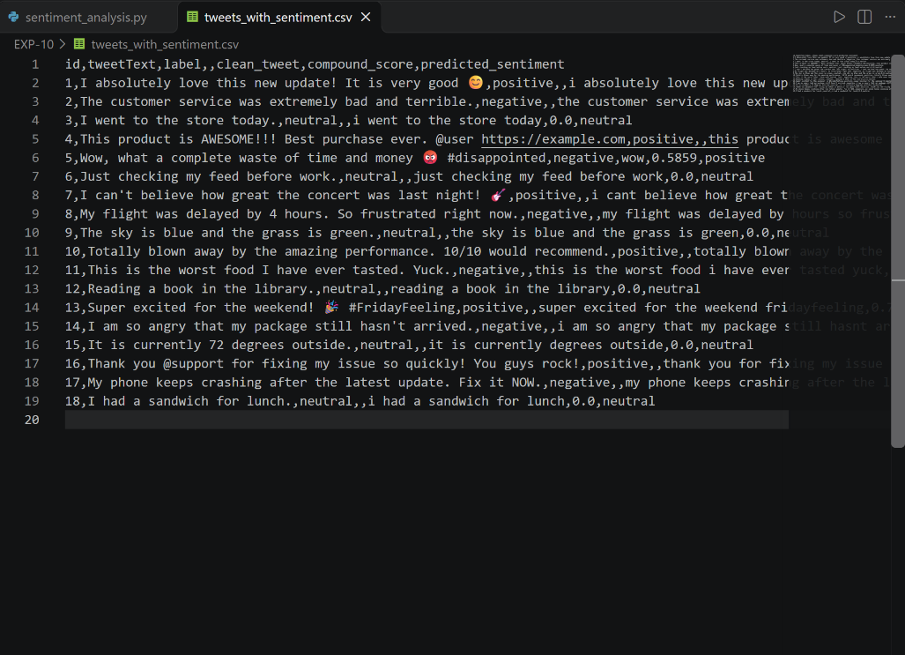  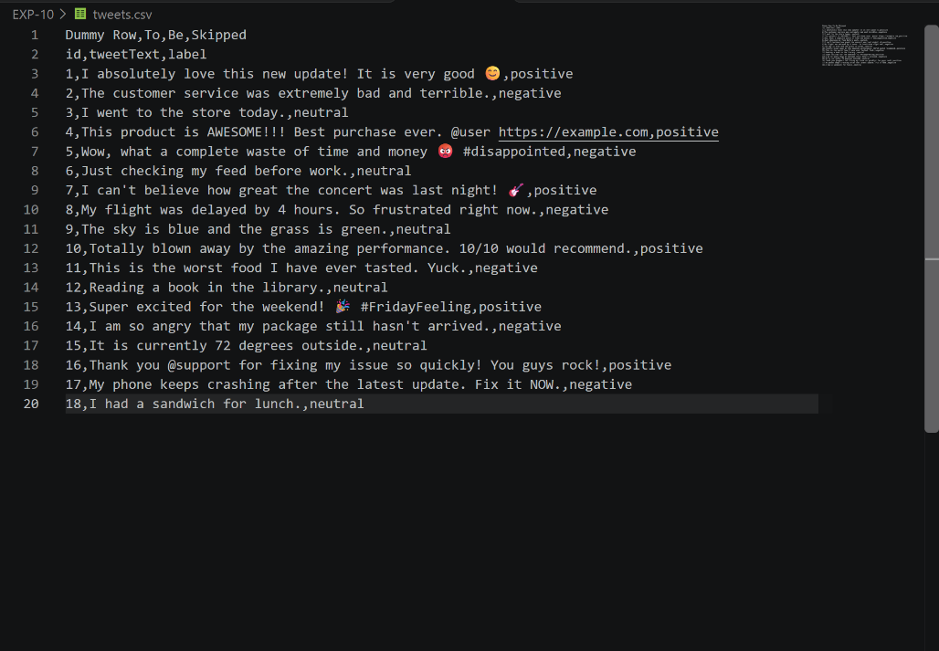  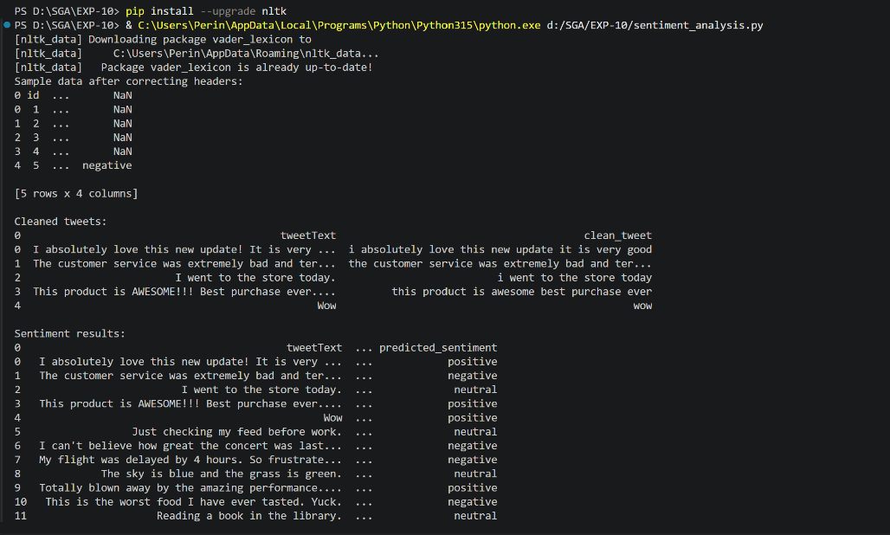  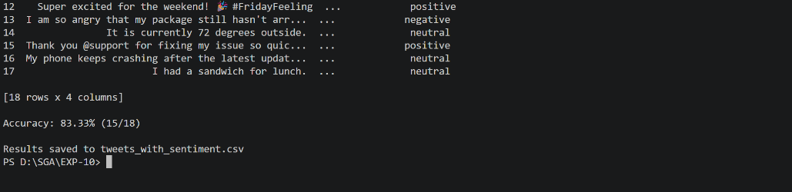
Conclusion | In this practical, we successfully performed sentiment analysis on tweets using Python and VADER. The VADER SentimentIntensityAnalyzer efficiently classified tweets as positive, negative, or neutral based on the compound score. This demonstrates how lexicon-based sentiment tools can analyze social media text quickly and accurately.

